Woodland View Early Years Centre
Newsletter
January – March 2024

Hope you all had a fantastic Christmas and a Happy New. I hope Santa was good to everyone.

New theme – Farmyard Fun

During our next theme we will be focusing on sensory fun linked to all things farmyard, including animals, food and of course tractors. Here are some of the stories we will be focussing on, they will involve lots of interactive props to engage the children.
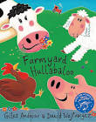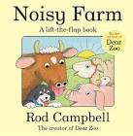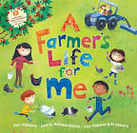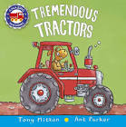

Messy play

We will be exploring some of the different textures you might find on the farm including hay, grass and wool and will also explore a variety of dry messy play items using tractors, diggers and toy animals. We will be making some muddy pigs but they will be inside ziplock bags for those who don’t like getting too messy! We will be putting animals in the ‘mud’ which will be cocoa pops and milk and then we will wash them in a bubble bath.

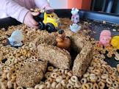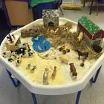

Art activities

During this theme there will be lots of fun art activities and we will be making a farm display for everyone to see. This will include using paper plates to make pigs and cows, hand prints to make chickens and using different textured materials to make a scarecrow. We will also be turning each pupil into a farmer and they will make their own tractors.

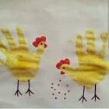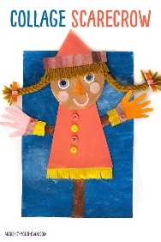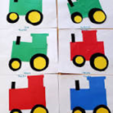

Home economics

During this theme we will be doing some simple home economics lessons such as
sheep biscuits with marshmallows, pig biscuits with icing and pink wafers and of course pancakes on shrove Tuesday. We will also be learning about the different fruits and vegetables that are grown on the farm. We will then be taking part in ‘fun with food’ as we will touch, smell, chop and taste a variety of fruit and vegetables. We will also use the fruit and veg during messy play activities.



And finally….
You will be receiving your Treat fund letter in January as always let us know if you would rather pay weekly. Please note that I can no longer give change so please send in the exact money. If you have any questions or queries please get in touch.

Many thanks.

Claire Beattie Simon Tonner
Principal Teacher Depute Head for Nursery and Primary

